CHARISMA Study - ED Clinician SOP

Index

- Key Aims
- Background
- Emergency Department Assessment and Management
- Completing the Clinical Assessment Tool

Key aims
1. To establish syndromic SARI (Severe Acute Respiratory Illness) surveillance using an existing clinical assessment tool and a novel multiplex point-of-care platform

2. To better characterise the epidemiology and seasonality of influenza A/B and SARS-CoV-2 among hospitalised SARI

Background

Surveillance for respiratory viral infections is an important public health activity as they cause substantial morbidity and mortality, particularly during the winter months. Before 2020, monitoring of influenza activity in hospitals involved capturing detailed data on all patients admitted to the intensive care unit with confirmed influenza infection.

With the emergence of SARS-CoV-2, there are now multiple respiratory viral pathogens of interest. Very low levels of influenza activity were observed last winter, likely due to behavioural and environmental interventions, such as physical distancing, limited foreign travel, as well as higher rates of influenza vaccination. However, with the easing of COVID-19 mitigation measures, and increase in mixing and travel, a resurgence of influenza and other respiratory viruses this autumn/winter is anticipated.

A syndromic approach to severe acute respiratory illness (SARI) surveillance encompassing rapid testing of flu and SARS-CoV-2 is needed to understand the evolving epidemiology of two viruses and their contribution to adult hospital admissions this winter. Additionally, early diagnosis of influenza & SARS-CoV-2 is crucial to allow clinicians to institute appropriate and timely treatment, and to ensure infection control measures are instituted to limit nosocomial transmission.

In the Emergency Department

Assessment

Roles

Staff nurse : responsible for screening patients at triage and requesting routine blood and microbiological investigations

Clinicians / Staff nurses / Support workers to collect the routine samples for patients presenting with acute respiratory illness.

Clinicians (Foundation Doctors/ Clinical Fellows/ Specialty Trainees/ Consultants): responsible for taking history, requesting chest X-Ray and completing SARI tool.

Patient screening

Staff nurses at triage will screen patients eligible for CHARISMA:

Inclusion criteria
- Aged >16 years
- Presenting with an acute respiratory illness
- Requiring testing for influenza (‘flu’) ± SARS-CoV-2 in the opinion of the treating clinician
- Requiring hospital admission

Exclusion Criteria
- Presentation with an acute respiratory presentation not felt to be due to infection
- Discharged from SATA or deceased
- Recent hospital admission within 14 days of presentation

Investigations

- At triage, all patients who meet these criteria should have the ‘CHARISMA-SARI’ Order Set requested on Trakcare. Please use this order set even if uncertain whether patient will be admitted
- Add “CHARISMA” in clinical details

The order set includes:

Haematology (purple and blue blood bottles)
- FBC
- COAG
- Ferritin

Biochemistry (yellow/gold & grey blood bottles)
- UE
- LFT
- CRP
- Bone Profile
- Lactate

Microbiology
- Sputum Culture (ensure ‘sputum’ is selected for general bacterial culture - not TB)
- Blood Culture

Virology
- Throat and nose swab for point of care testing (LIAT) & sent for laboratory-based flu/SARS-CoV-2/RSV PCR (ensure ‘Throat/nose – Vir’ selected for ‘SARS-CoV-2 (ED/IP use) (COVID-19 & ‘Resp Vir PCR’). Do not discard sample

A Cobas Liat PCR point-of-care test (“POCT) should be undertaken at this point from every patient who meets the initial criteria (irrespective of whether the patient will be admitted or not). Previously, the patient swab sample would be discarded/destroyed after POCT. It should be noted that following testing, the respiratory sample should be retained and sent to the West of Scotland Specialist Virology Centre for further testing (laboratory-based PCR ± sequencing) as part of the study.

“SARI – POCT done” should be entered into the patients triage clinical data at triage. The patient is then triaged and assessed by clinicians as normal – with full history and examination, and review with results when available. Patients will require a chest x-ray (CXR) as part of this process.

If the patient is deemed to require admission:- based on history, examination findings and investigation results - an entry into the TCAT (Turas Clinical Assessment Tool) should be made. This can be done by either medical or nursing staff, however we would anticipate medical staff would be responsible for ensuring this has been done for their patient in the majority of cases.

Exclusion criteria include:

Presentation with an acute respiratory presentation not felt to be due to infection
Discharged from ED or deceased
Recent hospital admission within 14 days of presentation

Completing the Turas Clinical Assessment Tool

Patients who require admission will require to have their data entered into the TURAS SARI Tool (“CAT”).

Log in to your TURAS account - you can find a link on the intranet via the GGCFavourites tab. The link to the tool (https://turassari.nes.nhs.scot) can be found on Microsoft Edge -> NHSGGC Favourites -> Covid Specific -> TURAS CHARISMA Study. You should then see SARI as one of your headings. If you cannot see this - please email nes.sari@nhs.scot.

It should take you to the following screen:

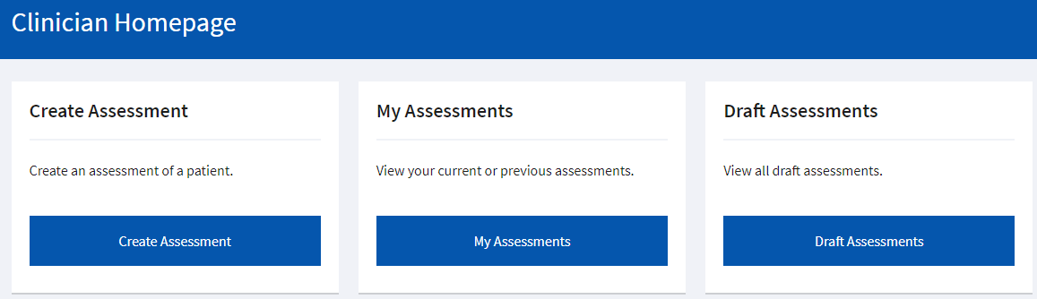

You should find the system easy to use and self explanatory. Items marked with an asterisk are compulsory data fields. The process should take no longer than two minutes.

Please complete each of the 3 tabs at the top of the screen:

- Patient*
- Assessment*
- Physiology
- Management

The first two tabs (*) are mandatory fields. Please try to complete Physiology and Management if you are able to. If time-pressured, please go to end of Management tab and press “Submit”. The research nurses will retrospectively complete the latter two fields.

Some key tips before you get started:

Please ensure you do not create duplicate entries for the same patient - you can search to see if there is already a form created.

You can leave this assessment and come back to it at any time - BUT - it is important that you have saved your progress as it does not save automatically.

Only click ‘submit’ once you are satisfied that you have submitted all the data required - the software will not allow you to submit without all required fields being filled in. If you do need to edit something once the form has been submitted - please email ggc.edresearchqeuh@nhs.scot.

Whilst the entry is in draft format - it can be edited by multiple people holding ‘clinician role’.

You can also access a list of assessments you have already completed - this will be great to keep in your portfolio as evidence of involvement in research/Quality Improvement. A ‘Certificate of Study Participation’ will be generated by the study PI, which can be uploaded to the ePortfolio.

FAQ

Do I need to take consent from my patient?

No - this trial is using a dataset that would ordinarily be taken from the patient anyway - history, examination and blood sampling, therefore you do not need to obtain formal consent. There will be posters visible in waiting areas however so you may be asked questions about the trial.

For further information, please refer to the CHARISMA website

https://www.emquire.care/project/charisma/

- SARI Tool Training guide
- SARI Tool User video – for a step-by-step guide to completing the SARI tool

